TI 22 – 64. Technology Example – UTROV Utility ROV tooling for Decommissioning - Rev 02
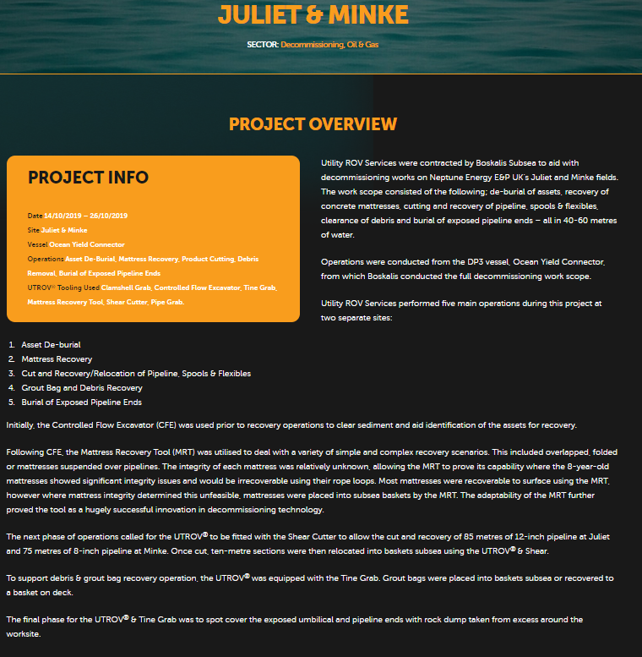
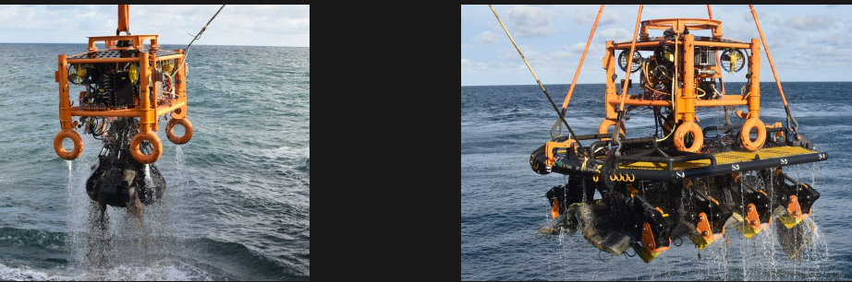
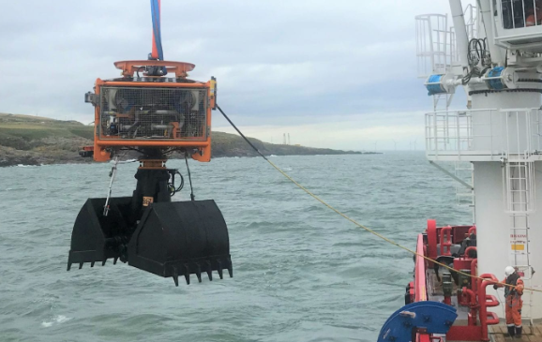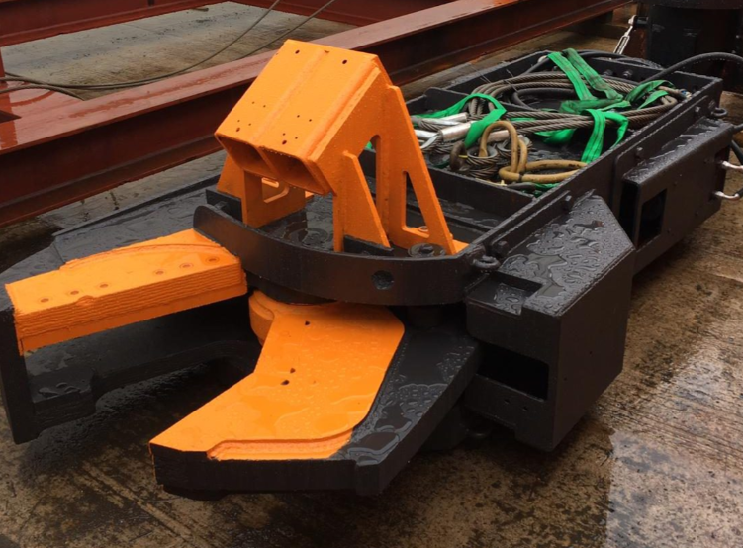

This is an example of this technology, Note: NSTA do not endorse or recommend specific technologies.
This is an extract from the Vendors website page for this product, the link for the full webpage is below for further information.
Link: Utility ROV Services » Juliet & Minke (utrov.com)

