TI 22 – 65. Technology Example – Aquaterra QUIKDECK Modular Deck Extension Rev 02
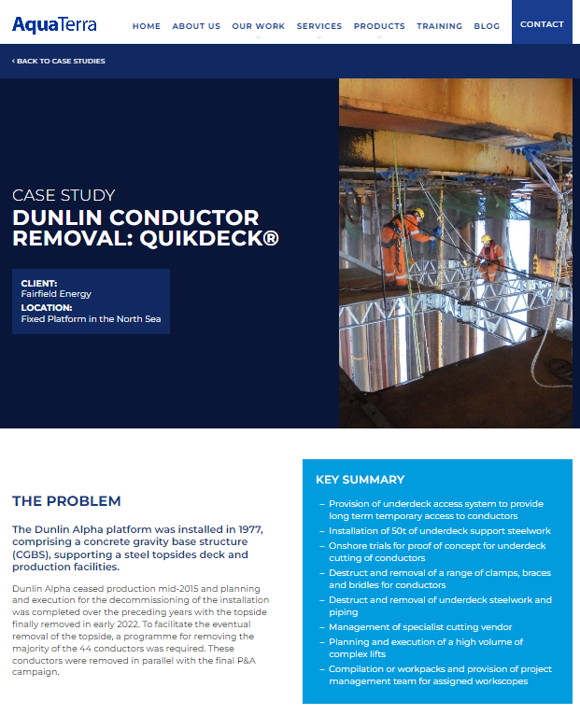 This is an example of this technology, Note: NSTA do not endorse or recommend specific technologies.
This is an extract from the Vendors website page for this product, the link for the full webpage is below for further information:
Link: Case Study: Dunlin Conductor Removal: QuikDeck® - AquaTerra

