TI 22 – 21 Technology Example – Bluespark Wasp Rev 02

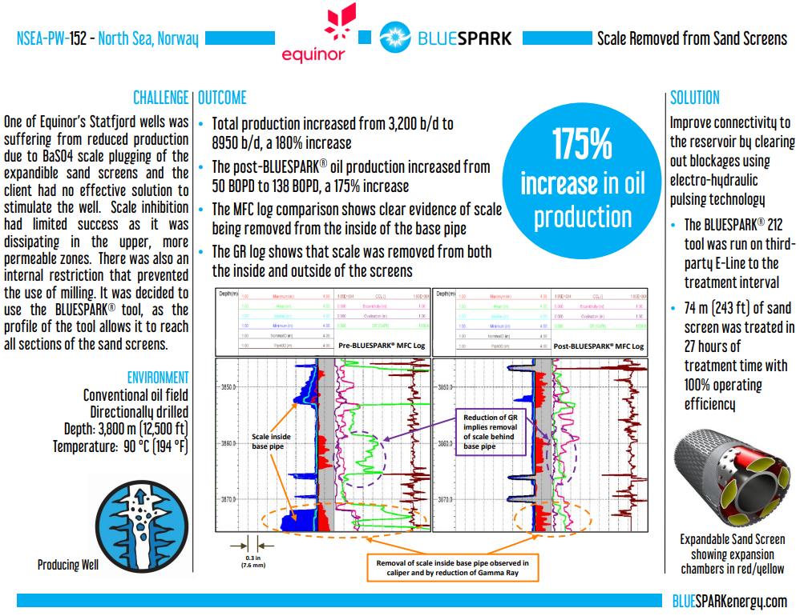

This is an example of this technology, Note: NSTA do not endorse or recommend specific technologies.
This is an extract from the Vendors website page for this product, the links for the full webpage and case study are below for further information:
Website Link: NSEA-PW-152 (Norweigan North Sea) — Blue Spark Energy
Case study Link: PowerPoint Presentation

