TI 22 – 47 Technology Example – Fugro Blue Essence USV - Rev 03
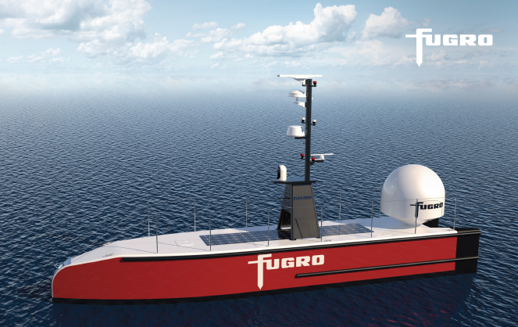
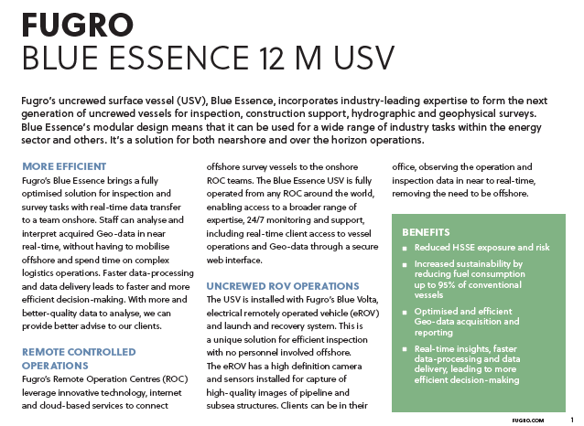

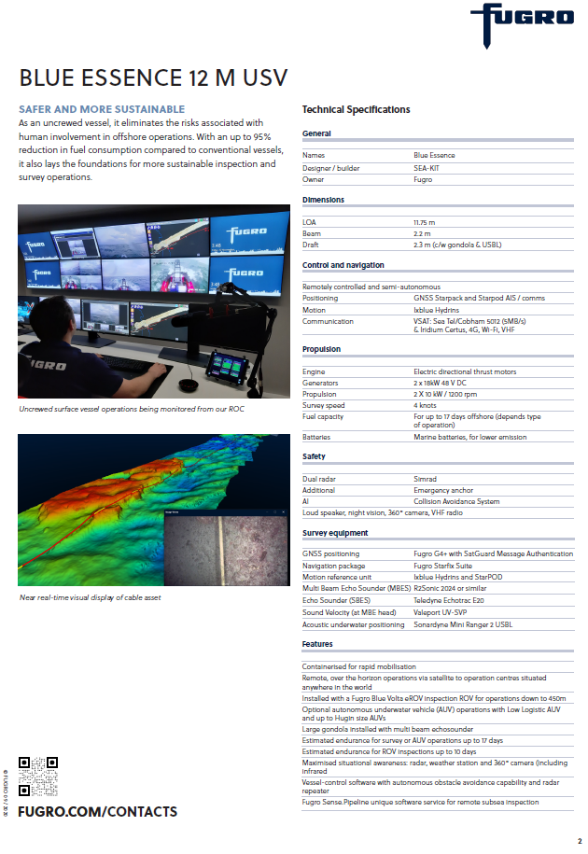This is an example of this technology, Note: NSTA do not endorse or recommend specific technologies. This is an extract from the Vendors website page for this product, the link for the full webpage is below for further information.

Remote inspection of pipelines using uncrewed vessels | Fugro
The latest information is available from the UKETP (Technology Catalogue) see link to this page below:
Blue Essence® | Technology Catalogue

