TI 22 – 54. Technology Example – ABB “ESP Automated Control Systems” Rev 02

ABB Web page snapshot:

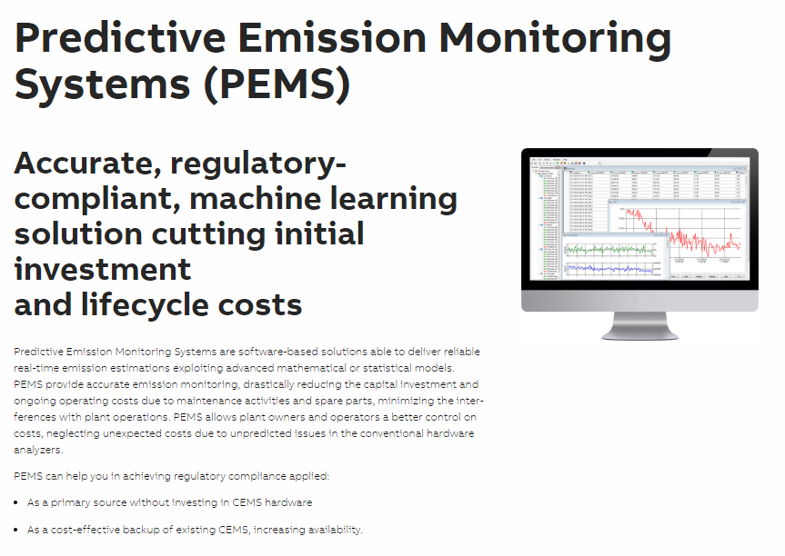
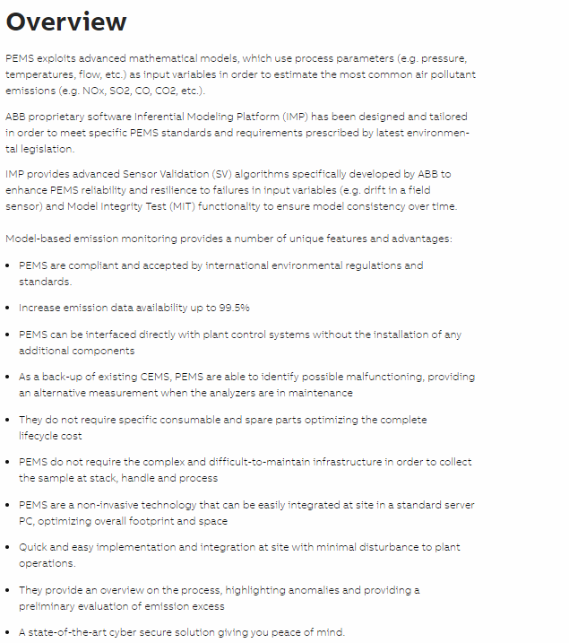
This is an example of this technology, Note: NSTA do not endorse or recommend specific technologies.
This is an extract from the Vendors website page for this product, the link for the full webpage is below for further information.

Link: Predictive Emission Monitoring Systems | Manufacturer | Supplier - Analytical Measurement | Products | Instruments | Equipment | ABB

