TI 26 – 01 Technology Example – NCS Multistage Frac system

INNOVUS™ frac-isolation assembly for pinpoint stimulation
Innovus frac-isolation assembly is deployed on coiled tubing or jointed pipe to locate and operate NCS Innovus frac sleeves. With more than 10,000 stimulation treatments and countless material and design refinements along the way, this is the most experienced and most robust pinpoint fracturing technology in the world. It has
continuously set new completion records throughout its history and currently holds the world record for most sleeves shifted and fracced in a single trip (228) and for most proppant pumped with a single frac-isolation assembly (18 million lb/8,165 t). No other coiled-tubing fracturing technology is as efficient and reliable in a sand-laden
wellbore environment. NCS pinpoint systems have been used at total measured depths up to 23,300 ft (7,102 m) and laterals up to 3 miles (4,828 m) long.
General features
- Streamlined profile for fast travel through the wellbore, higher injection rates, and longer tool life. Accommodates frac rates up to 80 bbl/min (12.7 m3/min).
- Hardened erosion-resistant surfaces extend service life.
- Recessed pocket slips are protected during travel through the wellbore.
- Circulation capability enables fast recovery from screen-outs.
- Dependable all-mechanical operation. Work string reciprocation cycles through four modes: 1) run in hole; 2) pull out of hole/locate sleeve; 3) open sleeve/pressure test; and 4) close sleeve.
- Proprietary extreme-service isolation packer seal. Robust EQ valve equalizes differential pressures before the isolation packer unsets, preventing damage to the packer seal.
- Innovative locate regulator ensures consistent sleeve locate and release forces and uniform signature for operational certainty.
- Pressure/temperature gauges record data at the frac zone and in the isolated wellbore below the isolation packer. Post-completion analysis reveals presence and type of inter-stage communication to assist with stage-spacing and frac design decisions.
- Advanced, patented sand-relief design, with strategic self-flushing channels that keep the tool free from contamination.
- Slim-hole versions are available for casing deformation or other
wellbore restrictions.
- Optional Shift-Frac-Close® sequence mitigates or eliminates the need for wellbore cleanouts by preventing proppant flowback and allowing formation pressures to stabilize before re-opening sleeves.
- Accommodates both annular (high-rate) and through-work-string (low-rate, controlled-growth) fracturing.
- Optional decompression sub accepts displaced fluid to enable the first sleeve to shift without formation access, eliminating the need for toe sleeves or toe perforating in many completions.
- Optional abrasive-jet perforator enables adding stages on the fly by fracturing between sleeves

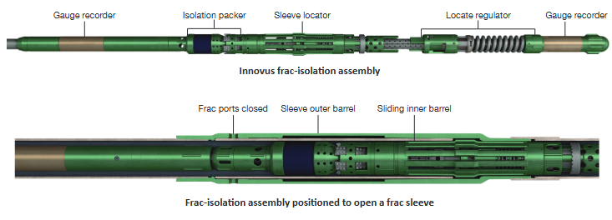

This is an example of this technology, Note: NSTA do not endorse or recommend specific technologies.

This is an extract from the Vendors website page for this product, the link for the full webpage is below for further information.

Link to Vendors website for further information:

Fracturing Systems – NCS Multistage

